

Injury & Illness Prevention Program

[Insert Facility Name]
[Insert Address]

[Insert Date]

Office of Environmental Health and Safety
Los Angeles Unified School District



LOS ANGELES UNIFIED SCHOOL DISTRICT

HEALTH AND SAFETY POLICY

The safety of students and staff is the highest priority for the Los Angeles Unified School District. Injuries and illnesses create personal loss to employees, students, and their families, and reduce the District’s ability to provide quality education. It is the District’s position that all accidents are preventable.

Site administrators have primary responsibility for providing a safe working and learning environment, and are accountable for compliance with applicable health and safety requirements. All supervisory employees, from senior managers to first line supervisors share responsibility for ensuring the safety of students and staff.

Every employee is expected to work safely, adhere to safety requirements, and immediately report accidents and potential workplace hazards to their supervisors.

Table of Contents

Page No.
1.0 Overview………………………………………………………………….. 4

2.0 Responsibilities…………………………………………………….. 4
2.1 Site Administrator……………………………………………………… 4
2.2 Supervisors……………………………………………………………… 5
2.3 Employees……………………………………………………………….. 5
2.4 Safety Committee……………………………………………………….. 5
2.5 Office of Environmental Health & Safety…………………………….. 6

3.0 Procedures………………………………………………………….. 6
3.1 Compliance…………………………………………………………….... 6
3.2 Communications……………………………………………………....... 7
3.3 Hazard Assessment & Correction……………………………………... 7
3.4 Accident Investigation & Reporting…………………………………... 8
3.5 Serious Incidents……………………………………………………....... 9
3.6 Training & Instruction…………………………………………………. 10
3.7 Recordkeeping………………………………………………………….. 10

4.0 Supplemental Plans & Programs…………………………… 10

Tables
Table 1 Health & Safety References……………………………………………….. 12
Table 2 Safety Committee Membership……………………………………............ 18
Table 3 Safety Incentives…………………………………………………………… 19
Table 4 Health & Safety Plans Required For LAUSD Facilities............................ 20
Table 5 Required Health & Safety Plans………….................................................. 21

Attachments
Attachment A LAUSD Health & Safety policy
Attachment B IIPP Summary Page
Attachment C Employee Request for Correction of Safety Hazard
Attachment D Health & Safety Training Form
Attachment E Facility Inspection Checklist
Attachment F Injury/Accident Investigation Report Form
Attachment G Safety Alert 03-03 District Response to Serious incidents
Attachment H Safety Alert 04-14 Accident Investigation and Reporting

Injury & Illness Prevention program
1.0 Overview
The California Code of Regulations (CCR), Title 8, Section 3203, require employers to maintain a safe and healthful workplace for employees. These regulations are enforced by the California Occupational Safety and Health Administration (Cal/OSHA). The regulations require a written Injury and Illness Prevention Program (IIPP) to specify responsibilities and procedures to protect employees and reduce losses resulting from injuries and illnesses.
It is the position of the Los Angeles Unified School District (District) that all accidents are preventable (LAUSD Health & Safety Policy, Attachment A). All employees, from senior managers to first line supervisors, share responsibility for providing a safe working environment. This requires that District facilities be maintained and operated in strict compliance with health and safety regulations.
This document is intended to assure compliance with 8 CCR Section 3203, and defines specific workplace safety responsibilities and procedures for all employees. This document was prepared using OEHS Template No. 12-01 Injury & Illness Prevention Program, and is organized into 4 sections. Section 1 is the overview. Section 2 outlines the responsibilities of the Site Administrator, supervisors, employees, and other District representatives. Consistent with Cal/OSHA Guidance, Section 3 includes specific procedures for compliance, communications, hazard assessment & correction, accident investigation & reporting, emergency incidents, training & instruction, and recordkeeping. Section 4.0 identifies other safety-related plans & programs that are required at [Insert Facility Name].

2.0 Responsibilities

2.1 Site Administrator

The Site Administrator has overall responsibility for ensuring site conditions and operations are in strict compliance with applicable health and safety requirements. Specifically, the Site Administrator is responsible for:

- implementing an Injury and Illness Prevention Program (IIPP) consistent with California Code of Regulations, Title 8, Section 3203;
- posting the IIPP Summary (Attachment B);
- taking action to mitigate identified safety hazards, including any temporary measures, as appropriate;
- establishing a Safety Committee and designating a Committee Chair to carry out the responsibilities referenced in Section 2.4;
- informing employees on procedures for reporting workplace hazards and safety concerns;
- instructing employees on procedures for reporting accidents, injuries, and workers’ compensation claims;
- continuing contact with injured employees; and
- reporting serious workplace injuries to Cal/OSHA as referenced in Section 3.4.

2.2 Supervisors
Supervisors are responsible for enforcing safe work practices and mitigating identified hazards. Other responsibilities include:

- providing new employees with an orientation of job hazards and safe work practice associated with their defined duties prior to assignment, including use of personal protective equipment;
- investigating accidents and taking necessary action to prevent recurrence;
- recommending disciplinary action for employees failing to comply with safety requirements;
- ensuring employees are trained on safe work practices and any hazards unique to their duties,
- ensuring proper reporting of work-related injuries and illnesses
- reporting workers’ compensation claims and continuing contact with injured employees; and
- maintaining employee training records.

2.3 Employees

Employees are responsible for following safe work practices and procedures as referenced in this document. Other responsibilities include:

- reporting unsafe conditions, work practices, or accidents to their supervisors immediately; and
- utilizing appropriate personal protective equipment as instructed by their supervisors.

2.4 Safety Committee
The Safety Committee is responsible for reviewing accident reports, regulatory notices, and workplace safety concerns. Other responsibilities include:
- reviewing work-related injury and illness statistics;
- making recommendations to the Site Administrator on necessary corrective actions;
- conducting periodic site inspections; and
- reviewing the IIPP and recommending necessary revisions to the Site Administrator.

2.5 Office of Environmental Health and Safety (OEHS)
OEHS is responsible for advising site administrators on regulatory requirements, and for conducting periodic site inspections to assess compliance with applicable standards. Other responsibilities include:
- developing policies and procedures for workplace safety;
- assisting administrators in preparation and implementation of the IIPP;
- conducting studies to evaluate potential workplace hazards, including exposure to chemical, physical, and biological agents;
- compiling injury and illness statistics to identify “high loss facilities”;
- evaluating factors contributing to elevated injury rates and preparing corrective action plans to reduce loss potential;
- issuing a corrective action notice following routine Safe School Inspections and complaint and emergency response; and
- preparing health and safety training materials and providing training, as requested.

3.0 PROCEDURES
3.1 Compliance
1. The Site Administrator shall be familiar with the health and safety standards, policies, and procedures referenced in Table 1. The Site Administrator should review and determine which of the listed requirements In Table 1 apply to their facility. OEHS is available to assist in this determination and can be reached at (213) 241-3199.

- The Site Administrator shall establish a Safety Committee to perform the responsibilities identified in Section 2.4. The Safety Committee is chaired by the Site Administrator or designee, and membership may include the Plant Manager, a union representative, and other employees selected by the Site Administrator. [Note: Schools may also include in the Safety Committee, the School Nurse, the Chemical Safety Coordinator, a representative of School Police, and parent or other designated member of the school community]. Present membership of the Safety Committee is shown in Table 2.

- The Site Administrator will review at least annually the information provided in this IIIP, and make necessary revisions. In conducting this review, the Site Administrator should consider changes in operations, personnel, regulatory requirements, or identified hazards.
4. The Site Administrator will ensure that the IIPP Summary (Attachment B) is posted in an area accessible to employees.

5. To help improve employee safety awareness, the Site Administrator may implement incentives, including: contests, recognitions and awards, and posters and advertising. Safety incentives for the current year are indicated in Table 3.

6. The Site Administrator will discipline staff members found responsible for contributing to unsafe conditions or work practices. Violation of safety procedures or policies will result in appropriate administrative action, including a notice of unsatisfactory service, suspension, termination and/or the satisfactory completion of an employee safety awareness program. The Site Administrator may call the Office of Staff Relations at (213) 241-6056 or Office of General Counsel at (213) 241-6601 for assistance.

7. Employees shall immediately report potential safety hazards, and may do so in the following manner:
- Direct reporting to immediate supervisor;
- Presenting concerns or potential hazards at scheduled staff meetings;
- Informing a member of the Safety Committee;
- Informing the Site Administrator through anonymous notifications;
- Reporting the condition to OEHS at (213) 241-3199; or
- Written documentation of the hazard by completing an “Employee Request for Correction of Safety Hazard” (Attachment C).

3.2 Communications
1. The Site Administrator will ensure the IIPP is accessible to all employees, and new employees are oriented on the contents of the IIPP. This orientation should be provided within 30 days of employment. The orientation should be documented using Health and Safety Training Form (Attachment D).
2. The Site Administrator will disseminate safety-related District Bulletins, Reference Guides, OEHS Safety Alerts and other documents to employees, as appropriate. This information may be disseminated during staff meetings, posted on bulletin boards or distributed electronically.
3. The Site Administrator will encourage employees to inform their managers and supervisors of potential workplace hazards. The Site Administrator will inform all employees on the procedures for reporting potential hazards as indicated in Section 3.1.7, and such reporting will not result in disciplinary action. Employees may also report unsafe conditions or work practices to OEHS at (213) 241-3199.

3.3 Hazard Assessment & Correction

- The Site Administrator will ensure that safety inspections are conducted at least twice a year or as often as necessary, and should use the Facility Inspection Checklist (Attachment E). The Site Administrator may refer to at the OEHS website at http://achieve.lausd.net/oehs for additional guidance.

2. The Plant Manager or designee will conduct a daily survey to identify any unsafe conditions and take action to ensure correction. Corrections may be made by facility staff or may require placement of a “service call” to the Facilities Maintenance & Operations at (213) 745-1600 or to other appropriate District offices.
3. The Site Administrator will ensure that all reported, new or previously unrecognized potential safety hazards are documented in a log for the purpose of facilitating necessary corrective action. These hazards shall be evaluated by the Site Administrator or the committee to determine appropriate follow-up actions.

4. If employees report a potential chemical, biological or physical exposure, the Site Administrator or his designee will assess the situation and determine the need for outside assistance. As appropriate, the Site Administrator may request assistance from local police and fire or OEHS at (213) 241-3199.

5. The Site Administrator will ensure that identified hazards are corrected in a timely manner. When an imminent hazard is identified which cannot be immediately abated without endangering employees, workers and other personnel shall be removed from the affected area and the area secured to prevent reentry except for designated workers. Workers entering the area to correct the unsafe condition shall be properly trained and provided with the appropriate personal protective equipment.

6. In determining corrective actions, the Site Administrator or designee shall evaluate whether the identified hazard can be eliminated through workplace redesign (i.e., engineering controls) or product substitution. If it is not possible to eliminate the hazard, consideration should be given to reducing the exposure duration or rotating the work assignment among employees. The use of personal protective equipment to control the exposure should be considered as the last resort.

7. The Site Administrator or designee shall ensure that identified hazards have been corrected in a timely manner based on the severity of the hazard when observed or discovered. This should include periodic review of prior inspections, regulatory agency reports, OEHS Corrective Action Notices, or Facility Inspection Checklists. This should also include examination of the Service Call Printout.
8. The Site Administrator or designee will ensure that when new substances, processes, procedures or equipment are introduced to the workplace, potential hazards are identified and evaluated by the appropriate supervisor.

3.4 Accident Investigation & Reporting

1. Following an occupational injury or illness, the Site Administrator or designee will:
- ensure injured or ill personnel receive necessary first aid or medical attention;
- ensure proper and prompt reporting of occupational injuries and illnesses outlined in LAUSD Reference Guide 1279.2 – Workers’ Compensation Procedures.
- take necessary action to prevent recurrence;
- investigate the accident, including inspection of the accident site and interview of employees and witnesses, to identify contributing factors and determine the cause(s) of the accident;
- complete the “Incident Report Form” (Attachment F) by submitting an Incident System Tracking Accountability Report, (refer to LAUSD Bulletin 5269.2 - Incident System Tracking Accountability Report); and
- follow-up with the injured employee.

- If medical treatment other than first aid is required, the Site Administrator will complete the Workers’ Compensation Claim Forms (see Reference Guide 1279.2).

- Consistent with Cal/OSHA regulations, the Site Administrator will report within 8 hours any serious injuries, illnesses or deaths to one of the Cal/OSHA offices listed below. The Site Administrator shall also notify OEHS at (213) 241-3199 whenever a Cal/OSHA notification has been made.
- Los Angeles (213) 576-7451
- Long Beach (562) 506-0810
- Van Nuys (818) 901-5403
- West Covina (626) 472-0046

For purposes of reporting, a “serious injury” is defined as a death, amputation, permanent disfigurement, hospitalization, or an incident resulting in multiple injuries requiring hospitalization. The following information will be required when reporting the injury:
  - Time, date, description of accident, and nature of the injury;
  - Employer’s name, address, and telephone number;
  - Name and job title of person reporting;
  - Address of accident site;
  - Name of person to contact at accident site;
  - Name and address of injured employee(s); and
  - Location of injured employee(s).

3.5 Serious Incidents
1. In the event of a “serious incident”, the Site Administrator will call 911 as appropriate, and notify School Police at (213) 625-6631 and OEHS at (213) 241-3199 (See Safety Alert 03-03, Attachment G). Note: A “serious incident” is any incident involving a death or serious injury, hospitalization, a chemical release that requires outside assistance, or incidents requiring the evacuation or closure of a room or facility.
2. School Police will notify OEHS at (213) 241-3199 or contact the designated emergency responder for serious incidents that occur after normal business hours and provide details of the incident.
3. The Site Administrator will determine the need for notifying the LAUSD Serious Incident Response Team (SIRT) comprised of representatives of the following offices: OEHS; the Local District; District Nursing Services; Student Medical Services; Employee Health Services; School Police; Office of Emergency Services; Office of General Counsel; and Office of Communications. Once activated, the members of the SIRT will convene on site to confer with the Site Administrator, investigate the incident and direct necessary response actions.
4. Following necessary response actions, members of the SIRT will evaluate site conditions and confirm that all necessary actions have been taken. The SIRT will provide written clearance to the Site Administrator that normal operations can resume.
5. In the event of an emergency, the Site Administrator should refer to the Facility Emergency Response Plan for specific action depending on the type of emergency.
3.6 Training & Instruction
- The Site Administrator will ensure all new and current employees receive appropriate health and safety training and supervisors familiarize themselves with the safety and health hazards to which employees under their immediate direction and control may be exposed. At a minimum, the training should include District safety policies and procedures, specific requirements of the IIPP, and other training with respect to hazards unique to the employees’ job assignments and when new or previously unrecognized hazards are identified. OEHS may be contacted for guidance at (213) 241-3199.
- Supervisors will train new and current employees on District safety policies and procedures, safe work practices, specific requirements of the IIPP, and training with respect to hazards unique to the employee’s job assignment. OEHS may be contacted for guidance at (213) 241-3199.
- Supervisors will ensure that employee training is documented using the Health and Safety Training Form (Attachment D). These forms shall be retained at the facility for at least five years.
4. Supervisors will ensure appropriate retraining of employees with new job assignments or, whenever new substances, processes, procedures or equipment are introduced to the workplace and represent a new potential hazard.
3.7 Recordkeeping
The Site Administrator will ensure retention of the following documents at the facility for at least five years:
- safety inspection reports
- regulatory citations and Corrective Action Notices;
- minutes from Safety Committee meetings;
- current year Cal/OSHA Form 300A “Summary of Occupational Injuries and Illnesses” (electronic copies of OSHA 300 Log and 300A Forms are maintained by OEHS.)
- employee accident investigation reports;
- workers’ compensation claims; and
- employee training records.

4.0 SUPPLEMENTAL SAFETY PLANS & PROGRAMS
All District facilities are required to have an Illness and Injury Prevention Program (IIPP). Depending on the type of facility and nature of operations, other safety-related plans and programs may also be required. Table 4 presents a matrix of required safety plans and programs for different types of facilities and operations. The Site Administrator should annually review Table 4 to determine those supplemental plans and programs which are applicable. Following this review, the Site Administrator should indicate within Table 5 whether or not the specific plans or programs listed are applicable and sign and date accordingly.

TABLE 1

Health and Safety References

LAUSD Bulletins | Subject Matter | Date Issued
Bulletin C-51 | Responsibilities of Cafeteria Employees During Periods of Emergency | 4/24/2001
Bulletin J-3 | Zero Tolerance Policy Regarding Firearms on School District Property | 3/26/1998
Bulletin M-66 | Procedures for Protecting the Safety of Students During Class Activities | 2/18/1998
Bulletin Z-72 | Bioterrorism Preparedness Response: Health Perspective | 9/3/2002
Bulletin 11 | Science Experiments Presenting Fire Hazards: Hot-Air Balloons and Model Rocket Launchings | 4/23/2001
Bulletin 735.1 | Policy on Restroom Access, Cleanliness and Repair | 7/30/2007
Bulletin 962.1 | Organizing for Crisis Intervention | 12/7/2005
Bulletin 963.2 | Guidelines for Preventing Heat Stress | 8/18/2014
Bulletin 1325.1 | Visitors to School Campuses and Locked Campuses During Class Hours at All Schools | 12/7/2009
Bulletin 1633 | Policies Governing School Fund-Raising Activities of PTA, Approved Parent Group/PTO, and Booster Clubs | 3/29/2005
Bulletin 1645.2 | Infection Control Guidelines for Preventing the Spread of Communicable Diseases | 7/13/2015
Bulletin 1937.2 | Reporting Communicable Diseases | 8/31/2015
Bulletin 2047.1 | Hate-Motivated Incidents and Crimes – Response and Reporting | 6/15/2015
Bulletin 2356.0 | Oxygen Use in Schools | 3/1/2006
Bulletin 3772.3 | Injury and Illness Prevention Program Requirements | 8/26/2013
Bulletin 3845 | Live Animals in Classroom, Service Animals, and School Sponsored and Non-School Sponsored Activities Involving Animals | 7/31/2007
Bulletin 4480.1 | Policy and Procedures for the Acquisition and Use of Automated External Defibrillators (AEDs) | 11/5/2012
Bulletin 4570.0 | Pest Management Quick Reference Guide for Site Administrators | 2/1/2009
Bulletin 4948.2 | Medical Clearance and Return to Play Guidelines for Students Participating in Interscholastic Athletics and Select Auxiliary Units | 1/4/2016
Bulletin 4991.5 | Mandatory Posting of Regulatory Notices | 5/12/2016
Bulletin 4994.0 | Vendors at or Near School Campuses | 12/21/2009
Bulletin 5038.0 | Landing of Aircraft on School Sites | 2/5/2010
Bulletin 5047.1 | Act of Violence | 4/22/2013
Bulletin 5066.0 | Communication with Other Schools, Offices, Districts Regarding Incidents of Violence, Emergencies, Etc. | 3/31/2010
Bulletin 5212.2 | Bullying and Hazing Policy (Student-to-Student and Student-to-Adult) | 11/26/2014
Bulletin 5269.2 | Incident System Tracking Accountability Report (ISTAR) | 7/10/2013
Bulletin 5353.0 | Mechanical Rides on School District Property | 1/13/2011
Bulletin 5424.2 | Administrative Searches to Ensure School Safety | 10/26/2015
Bulletin 5433.1 | District Emergency Response and Preparedness | 3/8/2013
Bulletin 5460.0 | Accessing and Securing Sites During School Hours, Non-School Hours, and Holiday Breaks | 4/22/2011
Bulletin 5468.0 | Use of Cellular Telephones and Other Electronic Devices by Students | 5/4/2011
Bulletin 5469.2 | Lockdown and Rapid Relocation Procedures For All Schools | 6/26/2014
Bulletin 5547 | Procedures for Regulatory Agency Inspections and Industrial Hygiene Sampling | 8/8/2011
Bulletin 5798.0 | Workplace Violence, Bullying and Threats (Adult-to-Adult) | 7/16/2012
Bulletin 6084.0 | Use of School Facilities in an Emergency or Disaster Situation | 6/11/2013
Bulletin 6231.0 | Discipline Foundation Policy: School-Wide Positive Behavior Intervention and Support | 2/14/2014
Bulletin 6320.0 | Procedures for Handling Disturbances, or Demonstrations on or Adjacent to School Sites | 7/21/2014
Bulletin 6436.0 | Safe Use of Household Electrical Appliances and  Extension Cords at Schools and Offices | 1/21/2015
Bulletin 6488.0 | Drug, Alcohol and Tobacco-Free Workplace | 4/8/2015

LAUSD  Reference Guides | Subject Matter | Date Issued
Ref. Guide 886.3 | Health Advisory / Air Pollution Episode Procedures | 3/30/2015
Ref. Guide 1279.2 | Workers’ Compensation Claims Reporting | 1/19/2016
Ref. Guide 1563.3 | Chemical Safety Coordinators | 7/7/2014
Ref. Guide 1902.1 | Procedures for Re-entry and Clean-up of Fire-Damaged Buildings | 7/27/2005
Ref. Guide 1909.2 | Procedures for Fire Protection Systems | 2/25/2013
Ref. Guide 3930.5 | Daily Flushing Requirements for Drinking Fountains and Faucets | 7/13/2015
Ref. Guide 4035.1 | Management of Skin Infections (including MRSA) in School Settings | 11/2/2015
Ref. Guide 4149.1 | Disposal Procedures for Hazardous Waste and Universal Waste | 2/10/2014
Ref. Guide 4492.1 | School Traffic Safety | 7/23/2012
Ref. Guide 5311.0 | Skateboard Activity Guidelines | 11/15/2010
Ref. Guide 5314.1 | Procedures for Environmental Review of Proposed Projects | 3/7/2012
Ref. Guide 5354.0 | Implementation of the EPA’s Tools for Schools Program to Improve Indoor Air Quality | 12/1/2010
Ref. Guide 5451.1 | School Site Emergency/Disaster Supplies | 4/11/2013
Ref. Guide 5496.1 | Implementing a Safety Valet Program at Schools | 6/24/2011
Ref. Guide 5511.4 | Safe School Plans Update for 2014-2015  Prevention – Volume 1: Coordinated Safe and Healthy Schools Assessment/Practices  Response – Volume 2: Emergency Procedures/Practices  Recovery – Volume 3: Intervention & Recovery Procedures/Practices | 9/11/2014
Ref. Guide 5671.0 | Methane Safety Program Implementation Guidelines | 1/9/2012
Ref. Guide 5693.2 | Cal/OSHA Log of Injuries and Illnesses | 1/21/2015
Ref. Guide 5715.0 | Compliance Protocol for California Environmental Quality Act Mitigation Monitoring and Reporting Program | 4/16/2012
Ref. Guide 5741.0 | Emergency Response and Communication Procedures for the Release of Areas Closed Due to Emergency Incidents | 4/23/2012
Ref. Guide 5803.3 | Emergency Drills and Procedures | 3/2/2016
Ref. Guide 6537.0 | Inter-Campus/District-Wide Safety Communications Test | 7/27/2015

OEHS  Safety Alerts | Subject Matter
Safety Alert 01-01 | Short Term Actions on School Preparedness
Safety Alert 01-02 | Safe Mail Handling Procedures
Safety Alert 01-03 | Procedures Related to Suspicious Substances (White Powder, etc.)
Safety Alert 01-04 | Procedures for Responding to a Toxic Air Release
Safety Alert 02-03 | Chemical Handling Safety Procedures for Schools
Safety Alert 02-03A | Sharp and Dangerous Objects Found in School Playgrounds
Safety Alert 02-04 | Reporting Work Related Fatalities or Serious Injuries
Safety Alert 02-05 | Seismic Bracing
Safety Alert 02-06 | Dumpster Sanitation
Safety Alert 02-08 | Modifications to Building Materials That May Contain Asbestos
Safety Alert 02-09 | Reporting Employee Injuries to OSHA
Safety Alert 03-02 | Procedures for Responding to a Nuisance or Toxic Air Release
Safety Alert 03-03 | District Response to Serious Incidents
Safety Alert 03-04 | Homeland Security Advisory System Recommendations
Safety Alert 03-05 | Response to Elevated Terrorism Threat Level
Safety Alert 03-06 | Schools as Potential Targets of Terrorism
Safety Alert 03-07 | Response to Sewer System Back-Ups
Safety Alert 03-08 | Mercury Hazards
Safety Alert 03-09 | Preparations for Sheltering-in-Place
Safety Alert 03-10 | Preventing Lead Exposure During Construction and Renovation
Safety Alert 03-11 | Procedure for Disposal of Electronic Devices
Safety Alert 03-12 | Restricting Access to Attics, Roof-Tops and Crawl Spaces
Safety Alert 03-13 | Responding to Wildfire Ash Deposits in Schools
Safety Alert 04-01 | Sanitizers and Disinfectant Hazards
Safety Alert 04-02 | Reporting Safety Hazards
Safety Alert 04-05 | Machine Guarding
Safety Alert 04-06 | Respirator Use and Fit Testing
Safety Alert 04-07 | West Nile Virus Precautions
Safety Alert 04-08 | Emergency Preparedness – Recommendation for Parents, Teachers and School Administrators
Safety Alert 04-09 | Safety Precautions for Staff at School Sites Under Construction
Safety Alert 04-10 | Pedestrian Safety in Parking Structures
Safety Alert 04-11 | Holiday Safety
Safety Alert 04-12 | Annual Notification of Environmental Health & Safety Procedures
Safety Alert 04-13 | Dangers of Flyer and Rave-Style Parties
Safety Alert 04-14 | Accident Investigation and Reporting
Safety Alert 05-01 | Cal-OSHA Log of Injuries and Illnesses
Safety Alert 05-02 | Indoor Environmental Quality
Safety Alert 05-03 | Approval of Chemical Products for District Use
Safety Alert 05-04 | Water Damaged Plaster Ceilings
Safety Alert 05-05 | Plastic BB Guns (Parent Letter Attachment -- *.docx)
Safety Alert 05-06 | Student Dress Code/Uniform
Safety Alert 05-07 | School Traffic Safety Tips (click here for other languages )
Safety Alert 05-08 | Discharge of Photographic Chemicals
Safety Alert 05-09 | Reporting School Air Quality and Health Concerns
Safety Alert 05-10 | Modifications to Asbestos and Lead Containing Materials
Safety Alert 05-12 | Disposal Practices for Stormwater and Sewer Drains
Safety Alert 06-01 | Regulatory Requirements for Use of Volatile Organic Compounds
Safety Alert 06-02 | Joint LAUSD/City of Los Angeles Recycling Program
Safety Alert 06-03 | Vehicle Parking on School Playgrounds
Safety Alert 06-04 | EPA Uniform Hazardous Waste Manifest Form
Safety Alert 07-01 | Particulate Emissions from Laser Printers
Safety Alert 07-03 | Lunchbox and Emergency Equipment Bag Recall
Safety Alert 07-04 | Distribution of Foreign Manufactured Items
Safety Alert 07-05 | MRSA Prevention and Clean-up Procedures
Safety Alert 09-02 | Water Gel Crystals
Safety Alert 10-01 | Bat Rabies Precautions
Safety Alert 10-02 | Pedestrian Safety Precautions for Student Athletes (Click Here for Spanish)
Safety Alert 10-03 | Integrated Pest Management Program Policy and Procedures
Safety Alert 11-01 | In-Wall Tables and Benches (Click here for related Principal’s Safety Video or Principal & Custodial Staff Safety Video )
Safety Alert 11-02 | Concerns Regarding Low Levels of Radiation From Japan
Safety Alert 11-03 | Cal/OSHA Citation Reforms
Safety Alert 11-04 | Safety Valet Program
Safety Alert 11-05 | Preventing Heat-Related Illness
Safety Alert 11-06 | School Support During Classified Employee Transition
Safety Alert 12-01 | Improving Classroom Safety
Safety Alert 12-02 | Asbestos Warning Signs
Safety Alert 12-03 | Back-To-School Heat Stress Prevention
Safety Alert 12-04 | Occupancy Inspections for New Schools & Modernization Projects
Safety Alert 12-05 | Trash Dumpster Maintenance & Sanitation
Safety Alert 12-06 | Use of Clear Bags for Recycling
Safety Alert 13-01 | Water Intrusion Issues in School Buildings
Safety Alert 13-02 | Heating, Ventilation, and Air Conditioning Systems & Indoor Air Quality
Safety Alert 14-01 | Hazard Communication
Safety Alert 14-02 | School Traffic Safety
Safety Alert 14-03 | Warning Labels for California Proposition 65
Safety Alert 14-04 | Mediterranean Fruit Fly Eradication Project
Safety Alert 14-05 | Unauthorized Pesticide Use of Chinese Chalk
Safety Alert 14-06 | Safety of Artificial Turf Fields
Safety Alert 15-01 | Tablet & Computer Charging Cart Precautions
Safety Alert 15-03 | Student Furniture Inspection Final
Safety Alert 15-04 | Recall of Bostitch Electric Pencil Sharpener
Safety Alert 16-01 | Lead in Drinking Water Program Update
Safety Alert 16-02 | Firestick Plant
Safety Alert 16-03 | Summer Flushing Procedures for Drinking Water

TABLE 2
Safety Committee Membership
[Insert Facility Name]
[Insert Date]

Note: The names of Committee members should be inserted below, and the members should be asked to confirm their membership by signature. Table 2 must be updated annually by March 31st, or whenever Committee membership changes.
Name | Title | Signature
 | Chairperson

TABLE 3
Safety Incentives
The following safety incentives have been developed for the current year. [Note: Select and describe one or more of the following suggested safety incentives]

- Safety Contests

[Insert details]

- Recognition and awards

[Insert details]

- Posters

[Insert details]

- Publicity

[Insert details]

- Other

[Insert details]

TABLE 4

Health and Safety Plans Required for LAUSD Facilities

Plan or Program | Regulatory Reference | Applicability |  | Guidance
Plan or Program | Regulatory Reference | Non-Schools | Schools | Guidance
Injury Illness Prevention Program | 8 CCR ' 3203 | X | X | OEHS Template 12-01
Safe School Plan | CEC ' 35294 et seq., |  | X | Model Safe School Plan, Vol. 1
Emergency Response Plan | CEC ' 35294 et seq., | X | X | Model Safe School Plan. Vol. 2
Asbestos Compliance Plan and Asbestos Management Plan¹ | HSC ' 25915; 40 CFR ' 763.93 | X | X | OEHS Template 02-04
Integrated Pest Management Program | CEC ' 17610 | X | X | OEHS Template 02-05
Bloodborne Pathogen Exposure Control Program | 8 CCR ' 5193; 29 CFR ' 1910.1030 | X | X | OEHS Template 02-06
Laboratory Chemical Hygiene Plan² | 8 CCR ' 5417 |  | X | OEHS Template 02-07
Hazard Communication Program | 8 CCR ' 5194; 29 CFR ' 1910.1200 | X | X | OEHS Template 02-08
Lead Paint Management Plan³ | District Policy | X |  | OEHS Template 02-09
Confined Space Entry Program⁴ | 8 CCR ' 5157 | X |  | OEHS Confined Space Entry Program, No. 02-10
Respiratory Protection Program⁵ | 8 CCR ' 1529 | X |  | OEHS Respiratory Program, No. 02-11
Lockout / Tagout Program⁶ | 8 CCR ' 3314 | X |  | OEHS Lockout / Tagout Program No. 02-12

¹Does not apply to new construction if certified by architect or EPA building inspector to be constructed of non-asbestos containing material.
²Applies only to secondary schools with science laboratories or industrial arts.
³Does not normally apply to buildings constructed after 1978, unless operations include “trigger tasks” that expose workers to lead (8 CCR ' 1532.1).
⁴Applicable to operations where workers are required to enter tanks, vaults, or other confined spaces as defined in 8 CCR ' 5157.
⁵Required when employee job assignments require the use of respirators to limit exposure to regulated substances.
⁶When cleaning, adjusting, servicing or repairing pneumatic, hydraulic, chemical or electrical equipment where there is a potential for the release energy that may cause injury.

TABLE 5
Required Health and Safety Plans¹
[Insert Facility Name and Address]

Plan or Program | Required  Yes or No
Injury and Illness Prevention Program | Yes
Safe School Plan
Emergency Response Plan
Asbestos Compliance Plan and Asbestos Management Plan
Integrated Pest Management Program
Bloodborne Pathogen Exposure Control Program
Lab Chemical Hygiene Plan
Hazard Communication Program
Lead Paint Management Program
Confined Space Entry Program
Respiratory Protection Program
Lockout / Tagout Program

____________________________________ ________________________
Site Administrator Date

¹An Injury and Illness Prevention Program (IIPP) is required at all District facilities. In addition, other safety-related plans may be required as supplements to the IIPP. The specific plans and programs that are required depend on the type of operations and physical characteristics of the facility. Guidance for determining the plans and programs applicable to a specific facility is provided in Table 4, Health and Safety Plans Required for LAUSD Facilities. Each year, the Site Administrator should review Table 5, and document this determination by marking the appropriate boxes above and providing signature.

Attachment A
LAUSD Health and Safety Policy

LOS ANGELES UNIFIED SCHOOL DISTRICT

HEALTH AND SAFETY POLICY

The safety of students and staff is the highest priority for the Los Angeles Unified School District. Injuries and illnesses create personal loss to employees, students, and their families, and reduce the District’s ability to provide quality education. It is the District’s position that all accidents are preventable.

Site administrators have primary responsibility for providing a safe working and learning environment, and are accountable for compliance with applicable health and safety requirements. All supervisory employees, from senior managers to first line supervisors share responsibility for ensuring the safety of students and staff.

Every employee is expected to work safely, adhere to safety requirements, and immediately report accidents and potential workplace hazards to their supervisors.

Attachment b

IIPP Summary

INJURY & ILLNESS PREVENTION PROGRAM SUMMARY
[Insert Facility Name]

California Code of Regulations, Title 8, Section 3203, requires each employer to develop and implement an Injury & Illness Prevention Program (IIPP). The following is a summary of the IIPP for [Insert Facility Name].  Overall responsibility for ensuring site conditions and operations are in strict compliance with applicable health and safety requirements is designated to [Insert Site Administrator].  The Safety Committee is responsible for assisting the Site Administrator by:  - Reviewing work-related injury and illness statistics;  - Making recommendations to the Site Administrator on necessary corrective actions;  - Conducting periodic site inspections;  - Conduct accident investigations and recommend corrective measures to prevent the recurrence of similar accidents; and  - Reviewing the IIPP and recommending necessary revisions to the Site Administrator.  To ensure employees comply with applicable standards, the IIPP includes:  - Recognition/Incentive Programs  - Disciplinary Action  - Training/Retraining Programs  To ensure communications between employees and supervisors, the IIPP requires that safety-related information is disseminated via District bulletins, memorandums, safety grams or other pertinent documents. These materials will be distributed in the following manner:  - Posting on bulletin boards accessible to all employees; and  - Discussion at Safety Committee meetings, staff development sessions and during new employee orientation.  Employees should report safety hazards through the following methods:  - Direct reporting of safety/health hazards to immediate supervisor;  - Presenting safety/health concerns at staff meetings;  - Informing Safety Committee representatives of the hazard;  - Informing the Site Administrator through anonymous notifications;  - Submitting an “Employee Request for Correction of Safety Hazard Form.”  - Submitting an inquiry or complaint to OEHS at (213) 241-3199.  Hazards will be assessed and corrected in the following manner:  - Safety Inspections will be conducted as often as necessary or at least twice a year.  - The Plant Manager or designee will conduct a daily survey to identify and correct unsafe conditions.  - The Site Administrator will ensure that identified hazards are corrected in a timely manner.  - When imminent hazards are identified which cannot be immediately abated, engineering controls, administrative controls or appropriate PPE must be used.  - Temporary control measures such as barricading or tagging will be used to mitigate hazards that cannot be corrected immediately by on-site personnel.  - The Site Administrator or designee will ensure that all identified hazards have in fact been corrected. | Following an occupational injury or illness, the Site Administrator or designee will take the following steps:  - Ensure injured personnel receive first aid or medical attention;  - Take necessary actions to prevent recurrence;  - Investigate the accident scene and interview victim and witnesses;  - Complete the “Incident Report Form” and submit the Incident System Tracking Accountability Report (ISTAR); and  - If medical treatment is required, complete the Workers’ Compensation Claims Forms and refer the employee to the appropriate medical provider.  - Ensure CAL-OSHA is notified within 8 hours of an employee’s serious injury. The following injuries are considered serious and must be reported to the nearest CAL-OSHA District Office (Los Angeles (213) 576-7451, Long Beach (562) 506-0810, Van Nuys (818) 901-5403, West Covina (626) 472-0046) within 8 hours of awareness: Death, Amputation, Permanent Disfigurement, and/or Hospitalization.  Employees will be trained in general safe work practices and will be provided specific instructions with respect to hazards unique to their job assignments. Employees will be retrained when introduced to new job assignments, new substances, processes, procedures or equipment use. Training should include the following:  - New employee safety orientation  - Emergency procedures  - Hazard Communication  - Bloodborne Pathogen  - Asbestos Awareness  The Site Administrator will ensure retention of the following documents at the facility for at least 5 years:  - Safety inspection reports;  - Regulatory citations and Corrective Action Notices;  - Minutes from Safety Committee meetings;  - Cal/OSHA Form 300 “Summary of Occupational Injuries and Illnesses”;  - Accident investigation reports; and  - Training records  For more information, employees should see their supervisor or may contact OEHS at (213) 241-3199.  Prepared: 8/12/2016

Attachment C
Employee Request for Correction of Safety Hazard

LOS ANGELES UNIFIED SCHOOL DISTRICT
EMPLOYEE REQUEST FOR CORRECTION OF SAFETY HAZARD

This form is to be completed when a hazard or dangerous situation has been noted by an employee. It is the responsibility of the Site Administrator to ensure that follow-up and corrective measures are taken.

Employee

To: _______________________________________________________

This is a request that the following safety hazard be investigated and/or corrected.

Dept. ___________________________ Bldg. ___________________ Room _______________

Location of hazard: _______________________________________________________________

Description of hazard: ___________________________________________________________

______________________________________________________________________________

Were measures/actions taken to temporarily control the hazard? [ ] Yes [ ] No

If yes, what? ___________________________________________________________________
______________________________________________________________________________

If no, give reason ________________________________________________________________

Signed: ______________________________ ___________________________ Employee Date

Site Administrator

[ ] 1. Recommendation: __________________________________________________ __________________________________________________________________ __________________________________________________________________
[ ] 2. Referred to the Office of Environmental Health and Safety
333 S. Beaudry Avenue, 21st Floor, Los Angeles, CA 90017
(213) 241-3199.

[ ] 3. Referred to the Plant Manager for immediate action.

[ ] 4. Referred to Maintenance and Operations Areas.

[ ] 5. Other (specify) _____________________________________________________

Signed: ______________________________ ___________________________ Site Administrator Date

Attachment D
Health & Safety Training Form

LOS ANGELES UNIFIED SCHOOL DISTRICT
Health and Safety Training Form

TRAINING LOCATION______________________________________________________________________________ DATE ____________________

The following employees have been trained in accordance with Title 8 of the California Code of Regulations in: (Please check one of the following.)

[ ] Bloodborne Pathogens [ ] Fire Prevention & [ ] Hazard [ ] Injury & Illness [ ] Occupational
Exposure Standard Emergency Evacuation Communication Prevention Program Hazardous
Section 5193 Sections 3220-3221 Section 5194 Section 3203 Chemicals in
Laboratories
Section 5191

[ ] Other (specify agency and applicable codes) ______________________________________________________________________________________

PRINT NAME SIGNATURE EMPLOYEE # JOB TITLE WORK LOCATION
__________________________ __________________________ _____________ __________________________ _________________________
__________________________ __________________________ _____________ __________________________ _________________________
__________________________ __________________________ _____________ __________________________ _________________________
__________________________ __________________________ _____________ __________________________ _________________________
__________________________ __________________________ _____________ __________________________ _________________________
__________________________ __________________________ _____________ __________________________ _________________________
__________________________ __________________________ _____________ __________________________ _________________________
__________________________ __________________________ _____________ __________________________ _________________________
__________________________ __________________________ _____________ __________________________ _________________________
__________________________ __________________________ _____________ __________________________ _________________________
__________________________ __________________________ _____________ __________________________ _________________________

________________________________________________________ ATTACH A COPY OF THE AGENDA AND LIST OF TRAINING MATERIALS.
Trainer or Site Administrator's Signature

Attachment E
Facility Inspection Checklist

FACILITIES INSPECTION CHECKLIST

Facility Name: ___________________________________________ Inspection Date: ___________________

Loc. Code: _____________ M&O Area: _________

ADMINISTRATIVE

1. Injury and Illness Prevention Program Yes No

Responsible person identified Comments: _______________________
Required inspection schedule met ________________________________
Accident investigations are prompt and thorough ________________________________
Program documents on file ________________________________
Staff received Hazard Communication training ________________________________

2. Emergency Fire and Earthquake Drills Yes No

Drills conducted per code; principal sign off Comments: _______________________
Elem. Fire drill one/month; 9-12 twice/year ________________________________
Elem. drop/cover drill once/qtr.; 9-12 once/sem ________________________________
Emergency preparedness plan available ________________________________
Supply location is orderly, clean ________________________________
Emergency response materials (e.g., kit) available ________________________________
and in accessible location ________________________________
Emergency/earthquake water changed every 3 yrs. ________________________________
Fire station testing log maintained ________________________________

3. Facility Site Safety Yes No

District-wide Safety Plan available Comments: _______________________
Site and buildings are free of fire hazards ________________________________
Fire extinguishers available in each building ________________________________
Fire extinguishers accessible, current ________________________________
Fire extinguisher inspections conducted monthly ________________________________
Exits marked and unobstructed, exit doors operable ________________________________
Fire lanes open/unobstructed ________________________________
Telephones available for emergency use ________________________________
Gates permit entry for emergency vehicles ________________________________
Accessibility for special needs students ________________________________
Free of unauthorized chemicals ________________________________
Cal/OSHA’s required notices posted ________________________________

4. Pest Management Program Yes No

Free of unauthorized pesticide/herbicide products Comments: _______________________
Program notifications/documentation on campus ________________________________
Exclusion work completed ________________________________
Food use areas identified ________________________________

Page 1 of 6
ADMINISTRATIVE (continued)

5. Trouble Calls Yes No

Trouble calls being made in a timely manner Comments: _______________________
Plant manager maintains a log of trouble calls and ________________________________
M&O response statuses ________________________________

BUILDINGS

6. General Building Maintenance Yes No

Buildings in good repair Comments: _______________________
Roofs/gutters well maintained ________________________________
Free of dry rot, water damage, exposed wires ________________________________
Floor covering in good repair ________________________________
Furniture and equipment has seismic restraints or ________________________________
bracing ________________________________
At least 18” clearance for sprinkler heads ________________________________
At least 36” clearance for electrical panels ________________________________

7. Drinking Water Yes No

Water fountains are functional, operable Comments: _______________________
Fixtures are clean; parts are not obstructed ________________________________
Water pressure is adequate ________________________________
Access and ration is sufficient ________________________________
Water is visibly clear ________________________________
District flushing procedures in place ________________________________

8. Graffiti Yes No

Free of graffiti on restroom walls, partitions, fixtures Comments: _______________________
Free of graffiti on building exteriors, windows ________________________________
Free of graffiti on building interiors, hallways, ________________________________
stairwells, rooms
Regular graffiti removal process in place, with ________________________________
matching paint-over

9. Asbestos Yes No

AHERA compliance maintained Comments: _______________________
Appropriate documentation on site (e.g. AHERA ________________________________
Management Plan) ________________________________
Interior building components in good condition ________________________________
Exterior building components in good condition ________________________________

10. Painted Surfaces Yes No

Interior building components in good condition Comments: _______________________
Exterior building components in good condition ________________________________

Pge 2 of 6
BUILDINGS (continued)

11. Electrical, Heating and Ventilation Yes No

Ventilation/heating/cooling systems in good repair Comments: ______________________
Lighting, alarms, cables are adequate ________________________________
Fixtures, switches and outlets are operable ________________________________
Maintenance requests kept on file ________________________________
Free of obvious safety hazards ________________________________

12. Windows – Operable, Safe, Clear Yes No

Windows provide light and unobstructive view Comments: _______________________
Any broken windows have been reported, ________________________________
Any broken windows repaired w/in 72 hours ________________________________
Any cracked windows have been reported ________________________________
Venetian blinds in good repair ________________________________
Free of obvious safety hazards ________________________________

13. Restrooms – Operable, Supplied, Clean Yes No

Toilets, sinks, and urinals clean and operable Comments: _______________________
Adequate ventilation ________________________________
Free of offensive odors ________________________________
Clean fixtures, walls, floors ________________________________
Stalls have doors with functional slide bolts ________________________________
Dispensers stocked w/paper, soap ________________________________
Daily restroom log maintained ________________________________
Lights, doors, windows, and hand dryers are operable ________________________________
Accessible during working hours ________________________________
Free of obvious safety hazards ________________________________
Last date of deep cleaning ________________ ________________________________

14. Kitchens Yes No

Pest problems have been managed Comments: _______________________
Drains clean ________________________________
Adequate cleanliness ________________________________
Fly fan provided, in operation _________________________________
Last date of deep cleaning ________________

15. Lunch Shelters Yes No

Pest problems have been managed Comments: _______________________
Drains clean ________________________________
Roof intact ________________________________
Lighting adequate/functioning ________________________________
Heaters functional (if applicable) ________________________________
Tables, trash receptacles and decks clean ________________________________

Page 3 of 6
BUILDINGS (continued)

16. Stairways/Hallways Yes No

Lighting adequate/functioning Comments: _______________________
Free of slippery conditions ________________________________
Free of obstructions ________________________________
Lockers in good repair ________________________________
Adequate cleanliness ________________________________
Handrails in good repair ________________________________

17. Gyms/Locker Rooms Yes No

Free of odors Comments: _______________________
Lighting adequate/functioning ________________________________
Lockers in good repair ________________________________
Hot water available for showers ________________________________
Backboards properly attached ________________________________
Floors free of safety hazards (not slippery or peeling) ________________________________
Adequate cleanliness ________________________________

18. Auditorium/Multi-Purpose Rooms Yes No

Lighting adequate/functioning Comments: _______________________
Drapes and dimmer board in good condition ________________________________
Free of broken/loose seats ________________________________
Adequate cleanliness ________________________________

19. Classrooms Yes No

Lighting adequate/functioning Comments: _______________________
Free of broken furniture ________________________________
Proper flags ________________________________
Adequate cleanliness, including sinks ________________________________
Glides on chairs ________________________________

20. Shops Yes No

Lighting adequate/functioning Comments: _______________________
Equipment has appropriate guards ________________________________
Safety lines clearly painted on floor ________________________________
Hot water available ________________________________
Adequate cleanliness ________________________________

21. Libraries Yes No

Lighting adequate/functioning Comments: _______________________
Shelving in good repair ________________________________
Carpet in good condition (no stains, ________________________________
broken seams, etc.) ________________________________
Adequate cleanliness _______________________________

Page 4 of 6
BUILDINGS (continued)

22. Administrative Office Yes No

Lighting adequate/functioning Comments: _______________________
Adequate cleanliness ________________________________

23. Hopper Rooms Yes No

Organized Comments: _______________________
Well stocked ________________________________
Adequate cleanliness ________________________________
Cleaning solutions are authorized and labeled ________________________________

GROUNDS

24. General Grounds Maintenance Yes No

Campus is clean, operational Comments: _______________________
Parking lines clear ________________________________
Game lines clear ________________________________
Litter removed daily ________________________________
Collection bin area is neat ________________________________
Chemicals stored safely and in appropriate locations ________________________________
Perimeter of school site/fencing is neat ________________________________
Site free of weeds ________________________________
Sewer/storm drains clear ________________________________
Exterior lighting is functioning/adequate ________________________________
Fences/gates in good repair (on track, has locks, ________________________________
no holes/rust) ________________________________
Asphalt in good condition (no significant cracks, ________________________________
holes, standing water, loose gravel/mulch, etc.) ________________________________
Custodial equipment/tools (mowers, carts, etc.) in ________________________________
safe, operable condition – i.e., guards, brakes, etc. ________________________________
and stored properly ________________________________

25. Playground Equipment Yes No

Equipment inspection on file at M&O District Comments: _______________________
Equipment is functional and in good repair ________________________________
Playground surfacing in good repair ________________________________

26. Landscape Yes No

Tree canopies adequately raised Comments: _______________________
Trees/plants adequately trimmed away from ________________________________
buildings ________________________________
Free of obvious hazards ________________________________

Page 5 of 6
I hereby certify that the above areas are either in good working condition or deficiencies have been forwarded to the appropriate office.

Inspector: ___________________________ ________________________

Print Name Title

___________________________ ________________________

Signature Date

Site Administrator: ___________________________ ________________________

Print Name Title

___________________________ ________________________

Signature Date

Page 6 of 6

Attachment F
INJURY/ACCIDENT INVESTIGATION REPORT

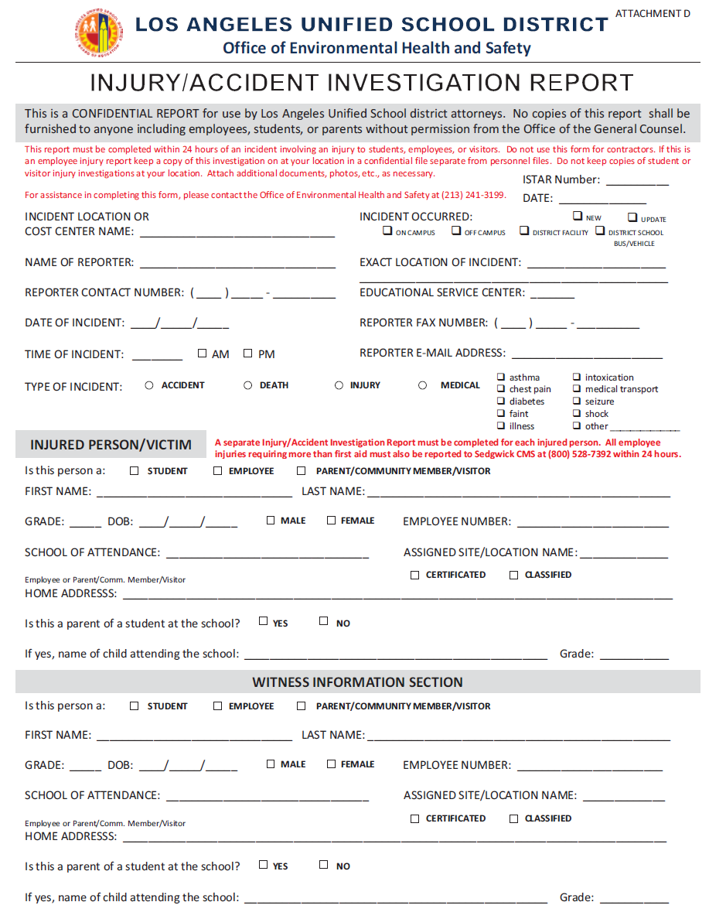
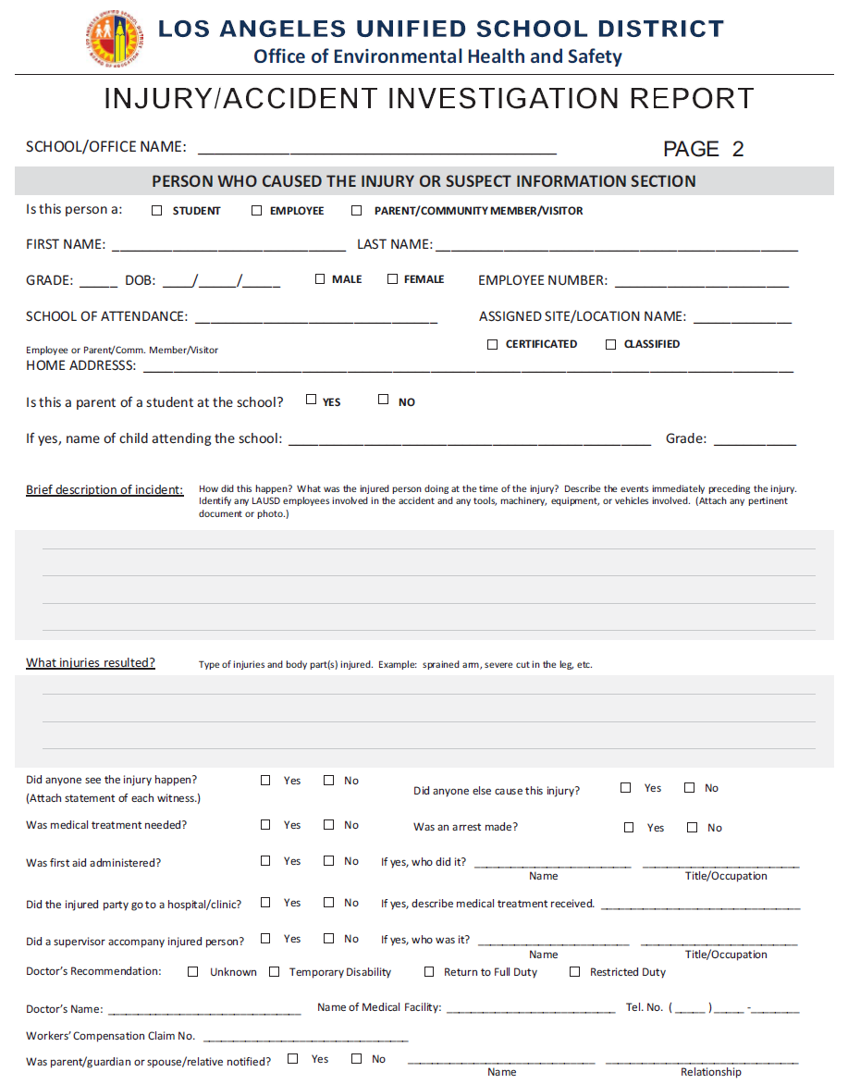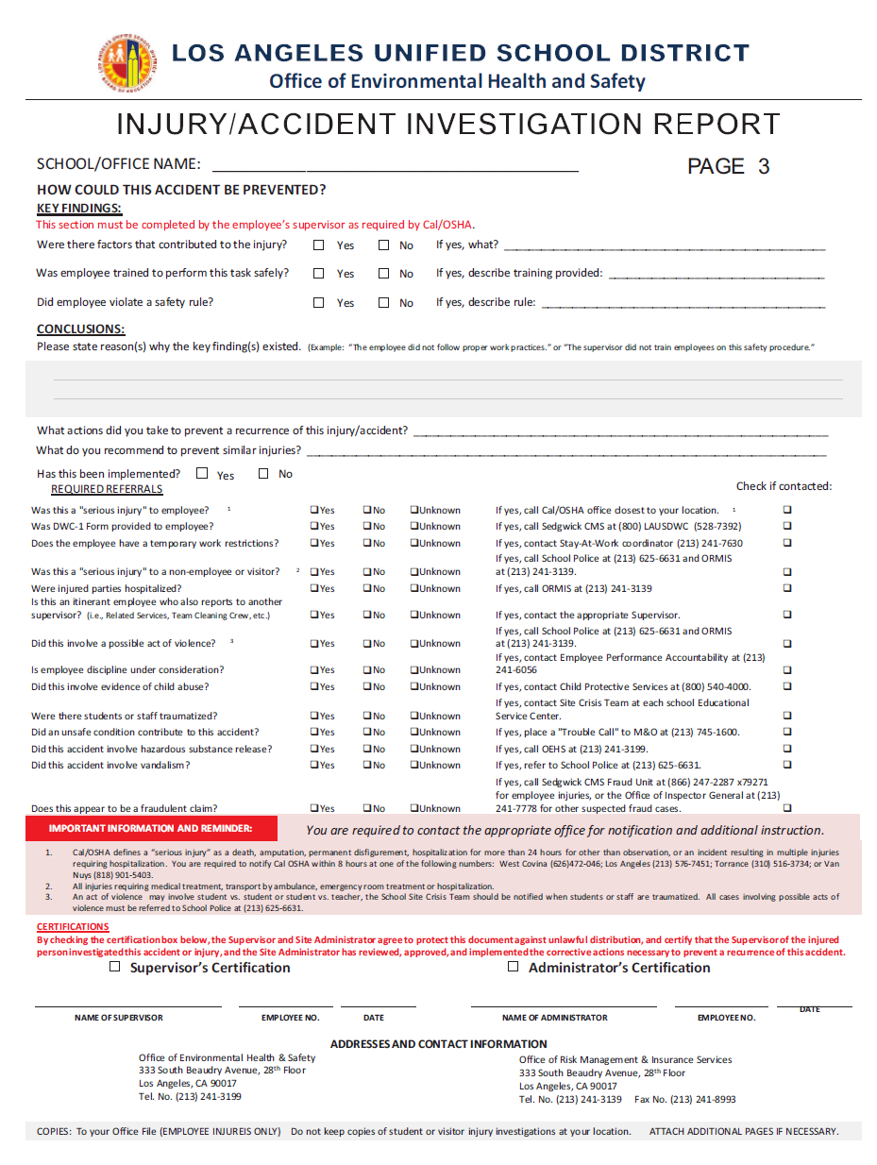
Attachment G

Safety Alert 03-03
District Response to Serious Incidents



SAFETY ALERT

No. 03-03 DISTRICT RESPONSE TO SERIOUS INCIDENTS March 2003

The District has established a Serious Incident Response Team (SIRT) to ensure effective response to “serious incidents.” A “serious incident” is any incident involving: a death or serious injury; a chemical release that requires outside assistance; the evacuation of personnel or closure of a room or area; or any other incident which in the judgment of the Site Administrator or designee warrants review by the SIRT. The SIRT may be comprised of representatives from the following organizations: OEHS; the Local District, Nursing Services; Student Medical Services; Employee Medical Services; School Police; Office of Emergency Services; Office of General Counsel; and Office of Communications.

In the event of a “serious incident,” the following procedure will be followed:

- The Site Administrator or designee will call 911, as appropriate, and notify School Police at (213) 625-6631.

- School Police will notify the Office of Environmental Health and Safety (OEHS) and provide details of the incident. The OEHS Duty Officer will ensure that the call is directed immediately to a Deputy Director or Manager.

- The Deputy Director or Manager will review the details of the incident to determine the need for activating the SIRT, and will notify the specific organizations necessary to participate in the response.

- Once activated, members of the SIRT will convene on site to confer with the Site Administrator, investigate the incident and direct necessary response actions. The Site Administrator will confer with the SIRT on the need to brief teachers, parents and community members.

- Following necessary response actions, members of the SIRT will evaluate site conditions and confirm that all necessary actions have been taken. The SIRT will provide written clearance to the Site Administrator that normal operations can resume.

Questions on this procedure may be directed to the Office of Environmental Health and Safety at 213-241-3199.

DISTRIBUTION: All Schools and Offices
Attachment H

Safety Alert 04-14
Accident Investigation and Reporting


Office of Environmental Health & Safety
333 S. Beaudry Avenue, 28th Floor
Los Angeles, CA 90017
Phone: (213) 241-3199
Fax: (213) 241-6816
SAFETY ALERT
No. 04-14 accident investigation and reporting DECEMBER 2004
Revised 4-12-12

California Occupational Safety and Health Administration (Cal/OSHA) regulations require employers to investigate and report all workplace injuries and illnesses. LAUSD developed the Injury Accident Investigation Report to comply with this requirement. This form must be completed within 24 hours of the incident and is used to document all accidents resulting in injury to students, staff and visitors.
The Injury Accident Investigation Report has been incorporated into the District’s electronic Incident System Tracking and Accountability Report (ISTAR) system. The system will automatically include the Injury/Illness Report tab when the following issue types are selected: accident, injury, medical treatment or death. A separate report must be completed for each injured person. See BUL-5269.2 Incident System Tracking Accountability Report (ISTAR) for additional information on ISTAR reporting procedures.
Serious injuries and accidents must be reported to OEHS immediately and may require notification of regulatory agencies or other LAUSD departments. For example, an employee injury that results in death, amputation, permanent disfigurement or hospitalization for more than 24 hours for other than observation, must be reported to Cal/OSHA within 8 hours. The bottom of page 3 of the Injury/Accident Investigation Report form indicates the appropriate agency or LAUSD office to notify with the applicable contact information.
The requirement to investigate an accident is NOT met by simply filling out an Injury/Accident Investigation Report. The form is used to document the facts, findings and conclusions after the investigation is completed. Accident investigations should be conducted by a person in authority that has a thorough understanding of the injured person’s job procedures and equipment; therefore, the investigation shall be conducted by the injured person’s direct supervisor. The following steps should be taken to ensure a proper investigation is conducted:
1. Determine if medical treatment is required and make appropriate arrangements, e.g., call 911, administer first aid, or refer injured party to District approved medical provider.
2. Go to the accident scene at once. Investigations should be made AS SOON AFTER THE ACCIDENT AS POSSIBLE. Delays, even a few hours, may permit information or items essential to the investigation to be removed, destroyed or forgotten.
3. Secure the accident scene to ensure the safety of others and to protect the "evidence" if necessary. This should include barricading or roping off damaged or involved equipment for further inspection. Take photographs if possible.
4. Talk with the injured person, supervisors, coworkers and any other witnesses privately and at the scene, if possible. Ask open-ended questions to get the facts without placing blame or responsibility. Repeat statements back to the individuals to ensure you have understood their meaning correctly. Request written statements from witnesses.
5. Study possible causes of the accident, and identify any unsafe conditions or acts which may have contributed to the accident. The purpose of this investigation is to determine the underlying causes that contributed so that corrective measures can be implemented to prevent others from being injured in a similar manner.
6. Ensure that all appropriate corrective actions identified in the investigation are completed.
For assistance in conducting an investigation, filling out the Injury/Accident Investigation Report or implementing necessary corrective action, contact the Office of Environmental Health & Safety at 213-241-3199 or http://achieve.lausd.net/oehs.

Sample of Injury / Accident Investigation Report generated through the ISTAR system.

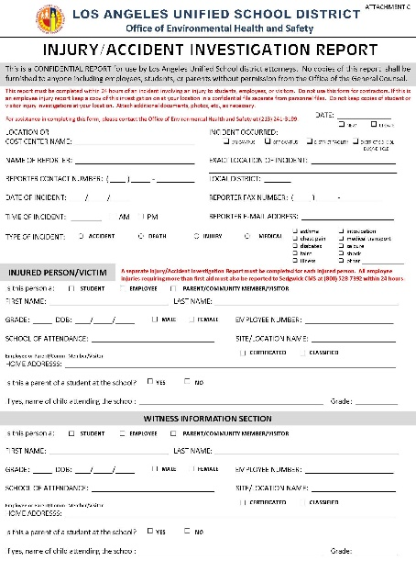 | 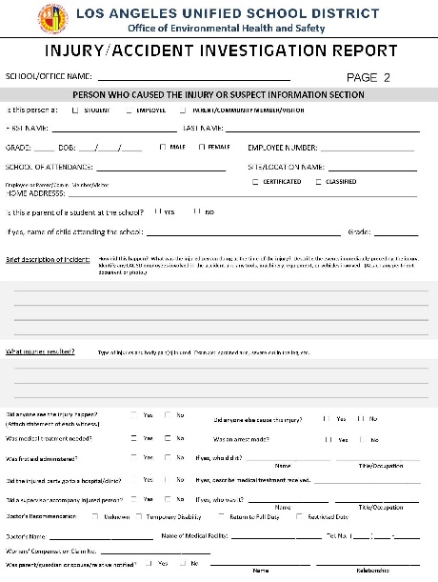 | 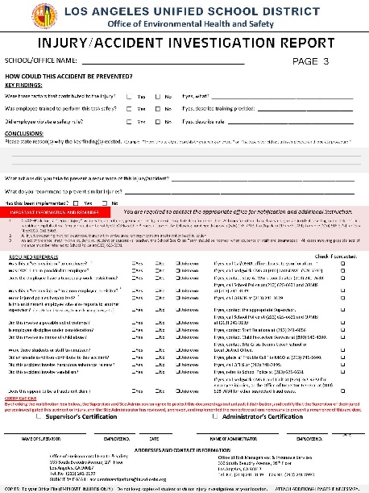

DISTRIBUTION: OEHS Website

